**Report on**

**Lab Assignment: Git Rollbacks, Merge Conflicts, Rebasing, and Reverting**

**Submitted to**

**LOVELY PROFESSIONAL UNIVERSITY PHAGWARA, PUNJAB**

**SUBMITTED BY**

**Name of student:** Anudari Ganbaatar

**Registration Number:** 12327086

**Part A: Setup and Initial Commits**

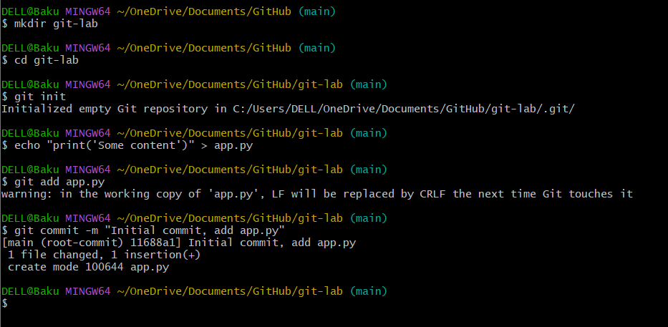

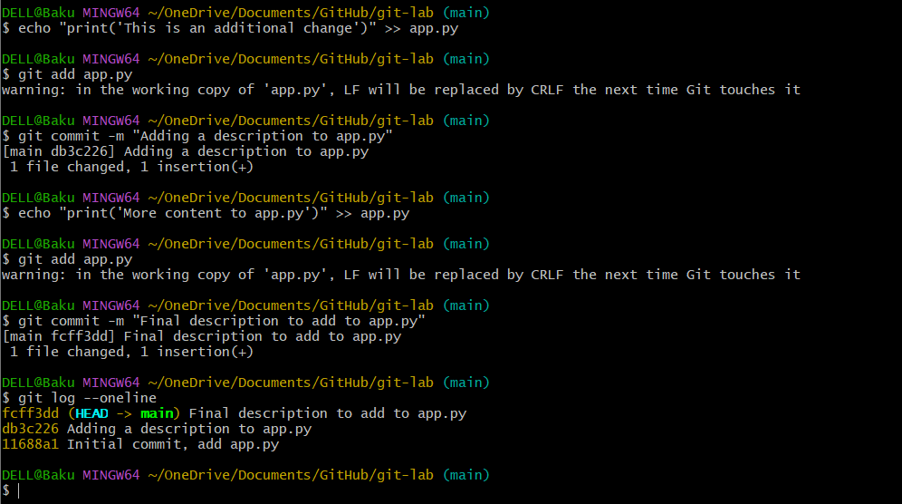

**Part B: Rollbacks in Git**

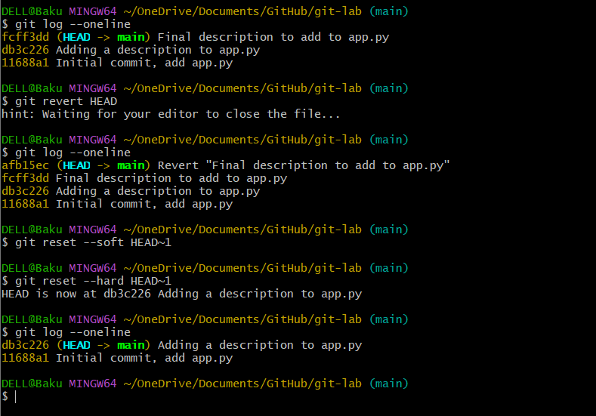



**Part C: Merge Conflict Resolution**

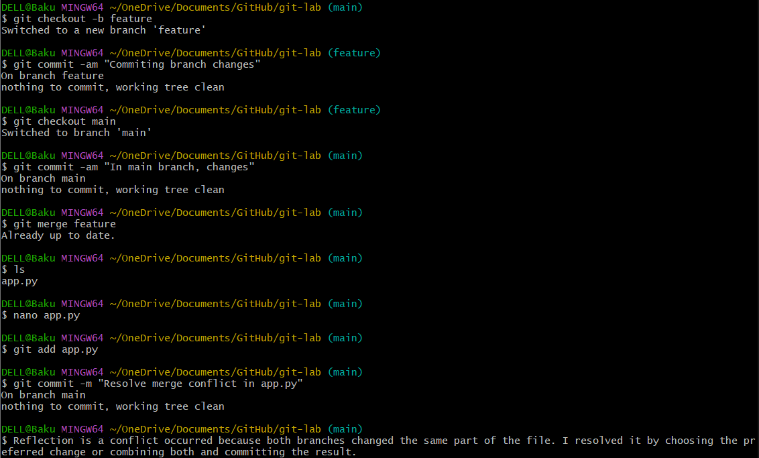

**Part D: Rebasing vs. Merging**

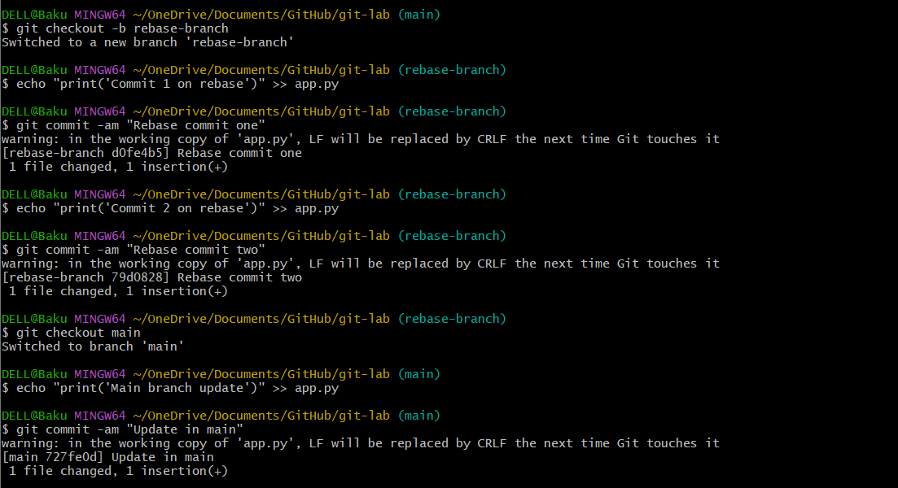

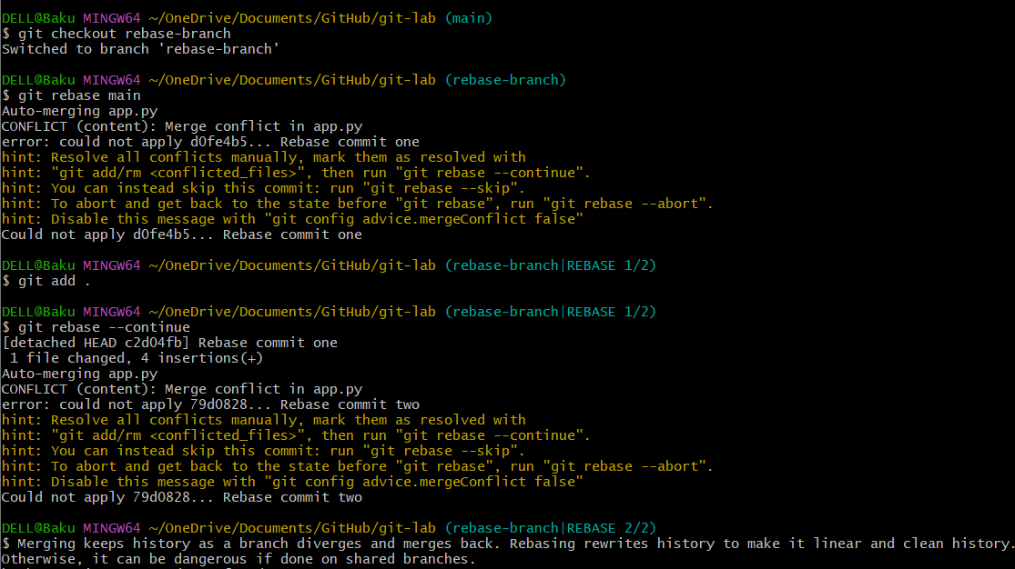

**Part E: Reverting a Specific Commit**

